ANGOLA
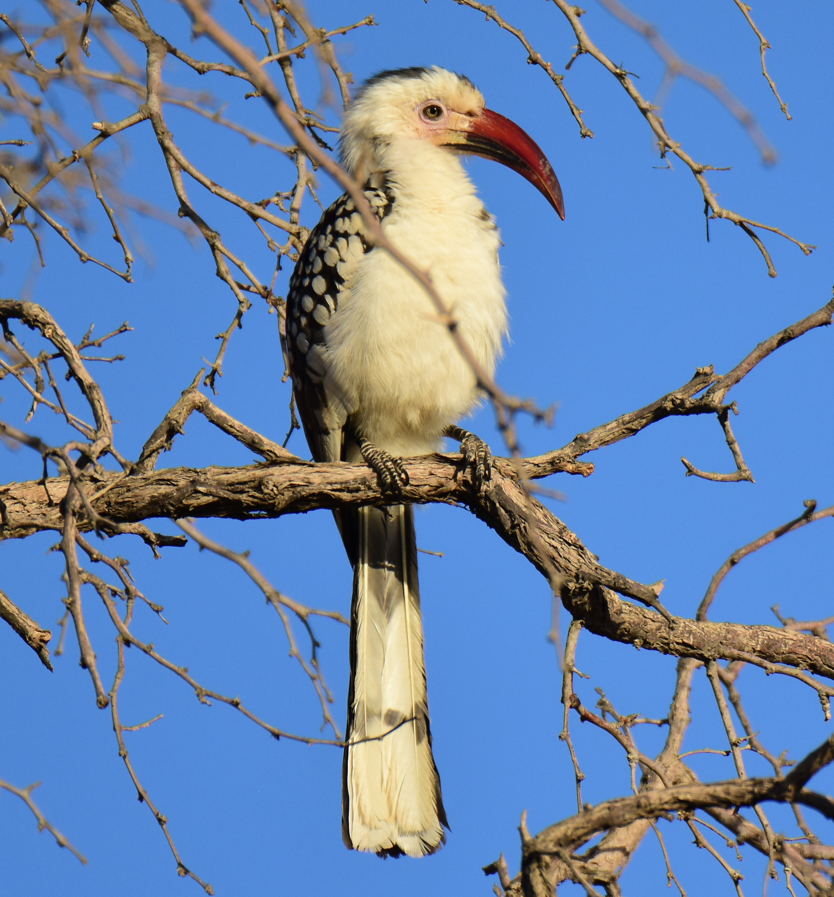
July 10 – 28, 2024
19 days / 18 nights
$9577*
Single Supplement $910

* Price based on a group of 10. Small-group surcharges will apply to groups smaller than 10.

Minimum group size is 5.
Maximum group size is 12.

Overview
After a prolonged Civil war this vast (nearly twice the size of Texas) and beautiful country is now once again stable and peaceful and open for tourism. With over 920 bird species, of which at least 15 are endemic (depending on taxonomy used) and a further 28 near-endemic, this is a true birder’s paradise and one of the least birded yet one of the most rewarding African countries to bird. We’ll target most of the endemic and near-endemic birds, from the spectacular Tundavala Escarpment in the south to the lush Guinea forests of the north. We expect a bird list in excess of 500 species, with some of the species only recently rediscovered and therefore only seen by relatively few birders to date.

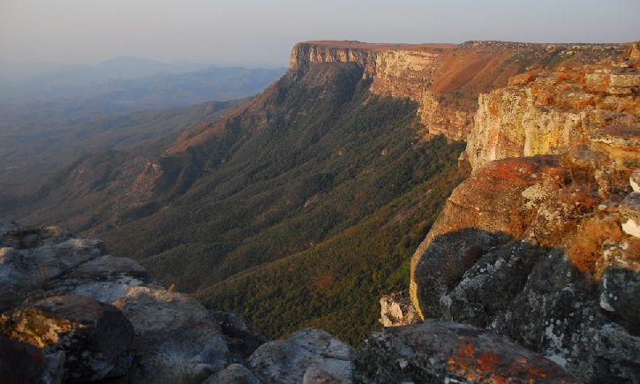
Lurking within its wild borders lies the continent’s second largest waterfall and, as is customary with all our tours, we’ll pay a deserved visit to this natural wonder, the spectacular Calandula Falls. Winding down the Tundavala escarpment, we will travel through Leba Pass, one of the most scenic passes in all of Africa, providing for some spectacular photographic opportunities whilst looking for some of the endemics occurring here. Angola might be a diamond in the rough, but deep within lies a country of surprising beauty, hosting an array of endemic birds, which on its own should make it one of the “must visit” African destinations.

Tundavala escarpment
Itinerary in Brief

Day 1 - Arrive in Luanda - Kwanza River Lodge
Day 2 - Quitexe area/Uige
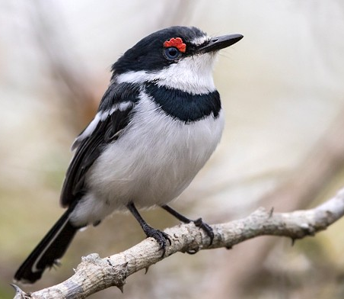
Day 3 - Quitexe area/Uige
Day 4 - Calandula area
Day 5 - Calandula area
Day 6 - Pedras Negras / Ndalatando
Day 7 - Ndalatando area
Day 8 - Ndalatando area/ Muxima
Day 9 - Muxima area
Day 10 - Kumbira Forest
Day 11 - Kumbira Forest
Day 12 - Kumbira Forest
Day 13 - Mount Moco
Day 14 - Mount Moco
Day 15 - South of Benguela / Lucira area
Day 16 - Tundavala
Day 17 - Tundavala
Day 18 - Tundavala
White-fronted Wattle-eye
Day 19 - Depart to Lubango for onward flight

Please note that this itinerary is subject to availability and no reservations have been made yet. Availability will determine the final itinerary and the costs will be adjusted accordingly. Prices are subject to foreign exchange fluctuations.

DETAILED ITINERARY

Day 0, July 9: Travel
You must leave the US on June 9 in order to arrive in Luanda on June 10. We recommend that you consider arriving a day early (depart on June 8 to arrive on June 9) to allow time to rest after the long fight and to begin to acclimate to the time change. We will arrange for lodging for you if you opt to arrive on June 9 and include the cost on your final invoice.

Day 1, July 10
You will have arrived in the city of Luanda this morning or yesterday. We’ll begin the tour with a short trip to the Cuanza River Mouth and Floodplain, which is about 40km south of the capital. Our first night will be in comfortable lodging and, time permitting, we’ll look for some of our targets here, which include the likes of White-fronted Wattle-Eye and Mangrove Sunbird.
Kwanza River Lodge (L/D)

Day 2, July 11
We have a fairly long drive ahead of us today to reach the northern scarp forests at Quitexe, but we will make the odd stop for some birding along the way. There is a fairly good chance of bumping into at least a target bird or two en-route, so we’ll keep our eyes peeled for the likes of Oustalet’s Sunbird, Meyer’s Parrot, Black Coucal, Brown-hooded Kingfisher, Black-backed Barbet, Banded Martin, Little Rush and Moustached Grass Warblers, Fan-tailed Grassbird, Whistling Cisticola, Pale Wren-Warbler, Salvadori’s Eremomela, and Blue-throated Roller. We should arrive at Uige mid- to late-afternoon.
IC Hotel or Grand Hotel do Uige (B/L/D)
Day 3, July 12
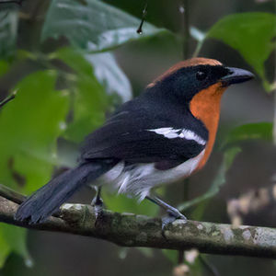
We have a full day to explore the lush evergreen and semi-deciduous Guinea Forest that projects southward from the Congo into Angola. The undergrowth has mostly been cleared, but the large shade trees that dominate the coffee plantations have been left. This makes a great habitat for birds and should provide some spectacular birding. Our prime target here will be the brightly-colored and rare endemic Braun’s Bushshrike, so we shall be listening for the tell-tale croaks that should alert us to its presence. Other possibilities include Buff-spotted Flufftail (more likely to be heard than seen), Western Bronze-naped and Afep Pigeons; Blue-spotted Wood Dove; Dusky and Olive Long-tailed Cuckoos; Mottled Spinetail; Speckled Mousebird; Black Bee-eater; Woodland and African Pygmy Kingfishers; Broad-billed and Blue-throated Rollers; Bristle-nosed Barbet; Least Honeyguide; Cardinal Woodpecker; Black Saw-wing; Lesser Striped Swallow; Slender-billed and Simple Greenbuls; Splendid Glossy Starling; Crested Malimbe; Black-necked, Vieillot’s Black and Village Weavers; Grey-headed, Chestnut-breasted and White-breasted Nigritas; Orange-cheeked and Common Waxbills; Bronze and Black-and-white Mannikins; and Red-headed Bluebill.
IC Hotel or Grand Hotel do Uige (B/L/D)
Braun's Bushshrike

Day 4, July 13
There will be some time in the morning to find some of the birds we might have missed yesterday. In this area we could literally stumble on any sort of avian surprise, which could include any of the following rarely recorded species: White-crested Tiger Heron, Hartlaub’s Duck, Congo Serpent Eagle, Cassin’s Hawk-Eagle, Red-headed Lovebird, White-bellied and Shining-blue Kingfishers, Black-and-white-casqued Hornbill, Bristle-nosed Barbet, Lyre-tailed Honeyguide, African Piculet, White-throated Greenbul, White-tailed Antthrush, Cassin’s Flycatcher, Red-bellied Paradise-Flycatcher, Western Black-headed Batis, Scaly-breasted Illadopsis, Fraser’s Sunbird, Pale-fronted Nigrita and Black-bellied Seedcracker. Take note, however, that we’ll be extremely fortunate in finding any of these rarities. After most of the early morning birding rush has subsided, we’ll start making our way to the Calandula area. Leaving the scarp forest behind, we’ll travel through some interesting Miombo woodland that covers vast parts of Angola. We’ll fit in a visit to the spectacular Calandula Falls, Africa’s second largest falls by expanse; it is well worth spending a bit of time taking in the breathtaking scenery here. We should arrive in camp with a bit of time to explore the surrounding woodland.
Pousada Calandula (B/L/D)

Day 5, July 14
Early morning departure to drive to the gallery forest where our main target for today resides - the highly localized White-headed Robin-Chat, a spectacularly beautiful bird that has only been seen by around 50 birders after its rediscovery a few years back. Our focus will soon shift to some of the other birds to be found here that include the likes of White-spotted Flufftail, Ross’s Turaco, Broad-billed Roller, Grey-headed and Blue-breasted Kingfishers, Double-toothed Barbet, Black-throated Wattle-eye, Yellow-throated Leaflove, White-chinned Prinia, Brown Illadopsis, Grey-winged Robin-Chat, Brown-headed Apalis, Bannerman’s Sunbird, and Dark-backed Weaver. Out in the miombo itself, we will search for the localized Anchieta’s Barbet, the stunning Anchieta’s Sunbird and Sharp-tailed Starling.
Pousada Calandula (B/L/D)
Day 6, July 15
There will be more time to explore the area before we make our way to Pedras Negros with some birding stops en-route. We’ll stop at some of the bridges to look for Red-throated Cliff Swallows, while we could also find the likes of African Marsh Harrier, Blue-breasted Bee-eater, and Fan-tailed Widowbird. After a visit to Pedras Negras, we’ll head to N’dalatando, where we will be spending the next two nights.
Hotel Terminus, Ndalatando (B/L/D)

Day 7, July 16
We make our way to the central scarp forests at N’dalantando this morning to explore the area in search of the likes of Red-fronted Parrots that screech overhead in search of food. An interesting selection of forest birds occur here, and we have a full day to search for Piping and African Pied Hornbills, Blue Malkoha, Naked-faced Barbet, Bocage’s Bushshrike, Black-winged Oriole, Honeyguide Greenbul, Yellow-browed Camaroptera, Rufous-crowned Eremomela, African Shrike-flycatcher, Sooty Flycatcher, Chestnut-winged Starling, Green-throated and Superb Sunbirds, Red-headed Malimbe, and Green-backed, Brown-eared and Yellow-crested Woodpeckers, among others.
Hotel Terminus, Ndalatando (B/L/D)
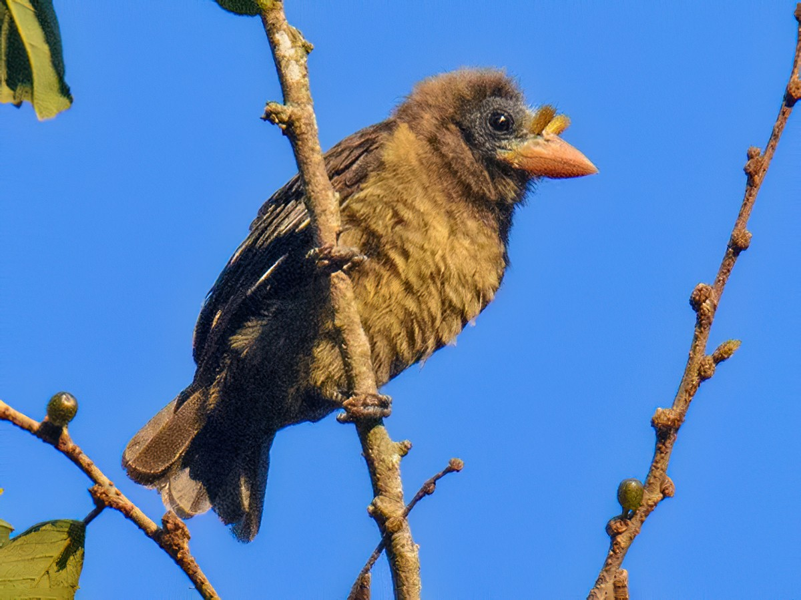
Day 8, July 17
Some early morning birding in the forest south of N’dalatando, where we’ve seen the rather elusive Tit-Hylia on previous visits. Both Naked-faced and Bristle-nosed Barbets nest in colonies in dead trees here. Further down the river we’ve recorded White-bibbed Blue Swallow, another rare bird for Angola that makes it onto only a few lists. From Ndalatando, we have a fairly short but scenic drive to the town of Muxima, where we’ll be staying at a small, rather peculiar hotel for one night, but it does allow us our best chance to find several endemics that occur in the area. Of particular interest
Bristle-nosed Barbet

here will be Grey-striped Francolin, Gabela Helmet-Shrike, Monteiro’s Bushshrike and White-fronted Wattle-eye. Our focus will be on finding the Francolin that occur commonly here on the road flanking the Cuanza River during the afternoon hours.
Ritz Muxima (B/L/D)

Day 9, July 18
We will spend some more time along the Cuanza River this morning before moving into the park after breakfast. We’ll enter Kissama National Park, which combines a mix of dry woodland and forest with the accompanying suites of birds. Our main endemic targets will be the enigmatic but fairly abundant White-fronted Wattle-eye, the mythical Gabela Helmetshrike, as well as Grey-striped Francolin. Other birds here include Olive Long-tailed Cuckoo (here at probably its southernmost reach), Narina Trogon, Yellow-bellied Greenbul, Monteiro’s Bushshrike, Forest Scrub Robin, and Yellow-bellied Wattle-eye. We’ll spend most of the day birding the park from east to west as we gradually work our way back to the coast where we’ll overnight at a lovely lodge on the beach.
Carpe Diem Resort, Caboledo (B/L/D)

Day 10, July 19
After an early breakfast we’ll make our way toward Gabela and, more importantly, Kumbira Forest which, for all intents and purposes, will be our most important birding stop on this tour. To make the most of this birding opportunity, we will spend three nights here in search of a whole host of endemics and other avian specialties. We will stay at a lovely guest farm not too far from the forest where we often find Freckled Nightjar hawking insects under the floodlights. Time permitting, we’ll do some birding in good patches of forest en-route.
Fazenda Rio Uiri, near Kumbira Forest (B/L/D)

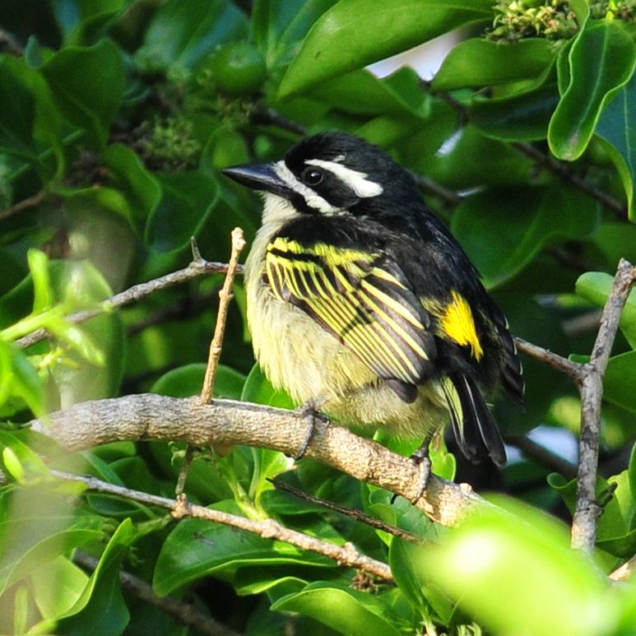
Days 11-12, July 20-21
Kumbira Forest is situated in the southern scarp and although the forest is no longer pristine, thanks largely to selective logging before the civil war, it is absolutely teeming with birdlife. Gabela Bush-Shrike has become a rather tough bird to find the last few years, but fortunately we discovered a new site during our scouting trips that should hopefully deliver the goods. We will also need to work hard for Gabela Akalat which, as with all
its congeners, tends to be shy and elusive. The endemic Hartert’s Camaroptera (split from Grey-backed) is common here and should present little problem tracking down. Pulitzer’s Longbill is probably the least common of the endemics, but we are hoping to find a calling male that will make tracking it down that much easier. Other highly sought-after species here include the diminutive Yellow-throated Nicator, Pale-Olive Greenbul, Rufous-vented Paradise-Flycatcher, Carmelite and Ludwig’s Double-collared Sunbird, and Red-headed Bluebill. Both Hairy-breasted and Naked-faced Barbets have distinct and localized sub-species here and might well end up being split as full species in future. Other good birds include Yellow-rumped Tinkerbird; Pallid Honeyguide; Brown-eared, Elliot’s and Buff-spotted Woodpeckers; African Broadbill; Petit’s and Purple-throated Cuckooshrikes; Brown Illadopsis; Black-throated and Buff-throated Apalises; African Yellow Warbler; Ashy Flycatcher; Blue-headed Crested Flycatcher; Perrin’s Bush-Shrike; Orange-breasted and Many-colored Bushshrikes; Mackinnon’s Shrike; Red-capped Robin-Chat; Southern Hyliota; and Black-throated and Yellow-bellied Wattle-eyes.
Yellow-rumped Tinkerbird
Fazenda Rio Uiri, near Kumbira Forest (B/L/D)

Day 13, July 22
This is mostly a driving day as we head south toward Mount Moco, with ample time for birding stops en-route. We hope to find a few more target birds as we traverse some spectacular woodlands with several stream/river crossings on the way on mostly good roads.
Chipipa Lodge (B/L/D)

Day 14, July 23
Early departure to Mount Moco as the lodge is a fair drive from the mountain. Swierstra’s Francolin, probably the most sought-after bird at this location, will be one of our biggest challenges on this tour. Please note that we will require a good dose of luck, perseverance, and plain old hard work to lay eyes on this one. The mountain also supports a number of other specialties, so there is plenty to look for. We will traverse various habitats, including an isolated patch of Afromontane forest, Miombo scrub, and associated grasslands in order to have the best chance of seeking out these specialties. In addition, we’ll keep a careful look overhead for Fernando Po Swift. Finsch’s Francolin and Angola Lark can be found in the grasslands. The scrub holds Black-collared Bulbul, Pale-billed Firefinch (a race of African Firefinch split as a full species by some authorities), and the local race of Red-faced Cisticola (sometimes split as Lepe Cisticola). In the stunted miombo, we’ll look for Bocage’s Sunbird and Dusky Twinspot. Other species to be found in the area include African Goshawk, Augur Buzzard, Peregrine Falcon, Kurrichane Buttonquail, Black-bellied Bustard, Coppery-tailed Coucal, Western Tinkerbird, African Pipit, Long-billed Pipit, Striped Pipit, Evergreen Forest Warbler, Rock-loving and Zitting Cisticolas, African and White-tailed Blue Flycatchers, African Hill Babbler, Spotted Creeper, Bronzy Sunbird, Red- headed Weaver, Red-collared Widowbird, Fawn- breasted Waxbill, Thick-billed Seed-eater
and Cabanis’s Bunting.
Augur Buzzard

Chipipa Lodge (B/L/D)
Day 15, July 24
Today will be another travel day, where we will head down to the coast, gradually descending into what is essentially an extension of the Namibian Skeleton Coast, with a totally different suite of birds. We should see the near-endemic Red-backed Mousebirds along the way as well as Bateleur, White-rumped Swift, Miombo Scrub Robin, African Stonechat, Sooty Chat, Croaking and Short-winged Cisticolas, Tawny-flanked Prinia, Pale Flycatcher, Black-crowned Tchagra, Holub’s Golden Weaver, Yellow Bishop and Yellow-fronted Canary.
Restinga Hote, Lobito (B/L/D)

Day 16, July 25
Heading slowly south, we’ll be on the lookout for some dry country birds more typical of Namibia. In the more vegetated areas and river beds, Grey-headed and Half-collared Kingfishers can be found. We should hear and see African Red-eyed Bulbuls singing cheerfully, and we can also expect to find Rüppell’s Parrot, charming Rosy-faced Lovebirds, the recently split Damara Red-billed Hornbill, Monteiro’s Hornbill, Rufous-tailed Palm Thrush, Pririt Batis, Carp’s Tit, and Meves’s Starling. The small local form of the Southern Yellow-billed Hornbill that occurs here is of interest and may well be split as a separate species in the future. Other birds to look for include Ludwig’s Bustard, Red-crested Korhaan, Namaqua Sandgrouse, Bare-cheeked Babbler, Karoo and Tractrac Chats, Mountain Wheatear, Kalahari Scrub Robin, Chat Flycatcher, the cute White-tailed Shrike (very common here), Pale-winged and Meves’s Starlings, Dusky Sunbird, Cape Sparrow, Lark-like Bunting, and an assortment of Larks, including Gray’s, Stark’s, Benguela Long-billed, and Sabota Larks. Leaving the desert plains behind, we’ll start ascending the escarpment toward Tundavala via the Leba Pass. Birding on the Leba Scarp can be very productive, so there will be a few stops along the way with targets such as Augur Buzzard, Grey Kestrel, Fülleborn’s Longclaw, Rockrunner, and the delightful Cinderella Waxbill. We will arrive at our lodge in the late afternoon.
Casper Lodge, Lubango (B/L/D)

Day 17 & 18, July 26-27
The Tundavala escarpment offers some of the most dramatic scenery in Angola and some pretty awesome birding to boot. We will have another shot at Swierstra’s Francolin here, although this enigmatic species will be no easier here than at Mount Moco. Other endemics we’ll be on the lookout for include Angola Cave Chat and Angolan Slaty Flycatcher. A bit of searching should also reveal Montane (Ludwig’s) Double-collared Sunbird. The local form of Yellow-bellied Waxbill is of interest here as it has now been split as a separate species and is known as Bocage's (or Angolan) Waxbill. Other birds include Lanner Falcon, Freckled Nightjar, Bradfield’s and Alpine Swifts, Black-collared Barbet, Greater Striped Swallow, Hartlaub’s Babbler, Striped Pipit, Short-toed Rock Thrush, Bocage’s Akalat, Wailing and Wing-snapping Cisticolas, Green-capped and Salvadori’s Eremomelas, Oustalet’s Sunbird, and Jameson’s Firefinch.
Casper Lodge, Lubango (B/L/D)
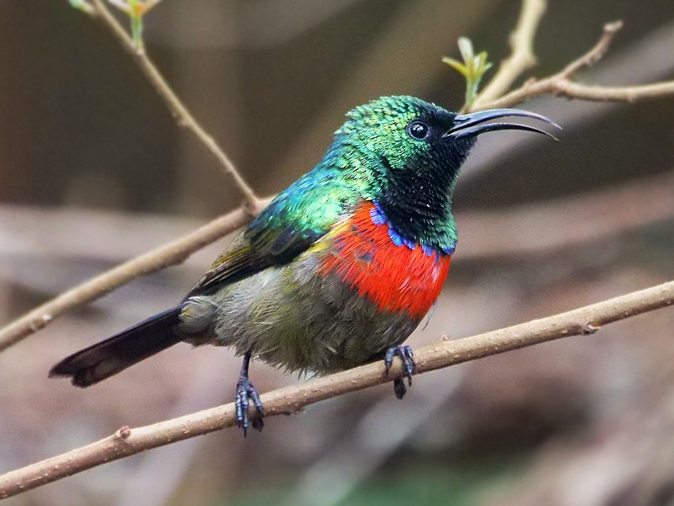
Montane Double-collared Sunbird
Day 19, July 28
Early morning birding will be dependent on the time of our flights out of Lubango; time permitting, we’ll search for any species we might have missed the previous day. We will transfer to the airport at Lubango at a time appropriate for flight schedules.
(B)

THE TOUR PRICE INCLUDES

~ All ground transportation within Angola in an 8-seat Safari vehicle
~ Invitation letters for Visas
~ Accommodation in lodges and hotels as indicated in itinerary
~ All meals as indicated in itinerary
~ Bottled water throughout the tour
~ Entrance fees
~ Services of an expert guide
~ Services of 2 Cheepers! tour guides (Jim and Cindy Beckman)
~ Pre-tour gift package, including customized checklist
~ Post-tour electronic copy of final checklist
~ Post-tour photo collection on USB drive

THE TOUR PRICE DOES NOT INCLUDE:

~ International roundtrip flight to/from Angola
~ Flight from Lubango to Luanda or Windhoek on day 19 (July 28)
~ Visa fees
~ Any drinks other than water or beer and wine during dinner
~ All optional activities
~ Items of a personal nature such as laundry, souvenirs, phone calls, etc.
~ Travel Insurance (highly recommended)
~ Gratuities

TERMS AND CONDITIONS:
~ Deposit of $1000 to secure your spot on the tour.
~ Balance is due 4 months prior to the start date for your tour.
~ Checks should be made payable to Cheepers! Birding on a Budget and mailed with the registration
form to:
Cheepers! Birding on a Budget
Post Office Box 385
Spring Valley, OH 45370
CANCELLATION POLICY:
Cancellation must be made in writing (email or snail mail)
More than 6 months prior to departure – full refund of deposit
Between 4 and 6 months prior to departure – 50% refund of deposit
Less than 4 months prior to departure – No refund of deposit
If cancellation occurs after full payment is made, a refund will be given only if the vacant spot is filled.
Trip insurance is highly recommended.
You can compare prices offered by various trip insurance companies at these websites:
http://www.quotewright.com/?sub_id=6056
www.insuremytrip.com
Cheepers! Birding on a Budget LLC reserves the right to make changes in the itinerary if the need should arise due to unforeseeable circumstances such as weather, landslides, and other natural phenomena, as well as suggestions by local guides in order to take advantage of an unusual birding opportunity. If changes are necessary we will attempt to maintain the itinerary as presented as closely as possible.
QUESTIONS? CONTACT US!
Contact us by email: cbeckman4505@gmail.com
jamesdbeckman@sbcglobal.net

Contact us by phone: 937-862-4505 (Beckmans’ land line; say your name when prompted)
937-974-0802 (Jim’s cell)
937-974-0803 (Cindy’s cell)

Contact us by mail: Cheepers! Birding on a Budget
PO Box 385
Spring Valley, OH 45370

